**<Search shortest route>**

**1. Introduction**

This app is for searching shortest route in selected cities.

User can select 4 cities in the list, and then select START city.

Result will be shown that shortest route with starting city.

It is calculated by straight line distance using Latitude and Longitude betwwen each city.

You can see location on the map also if you select "Show Map" button on the result screen.

minSdkVersion="21", targetSdkVersion="24"

**2. Download source code from Github.**

You can down source code of this app below :

*git@github.com:xSEUNGHANKIMx/VikingSearchRoute.git*

**3. Import in Eclipse**

This project is working in Eclipse. You can import this by selection root folder.

**4. Installation**

There is viking.apk file in the viking foler.

You can copy it to your Android device and install it.

**5. Screen Shot**

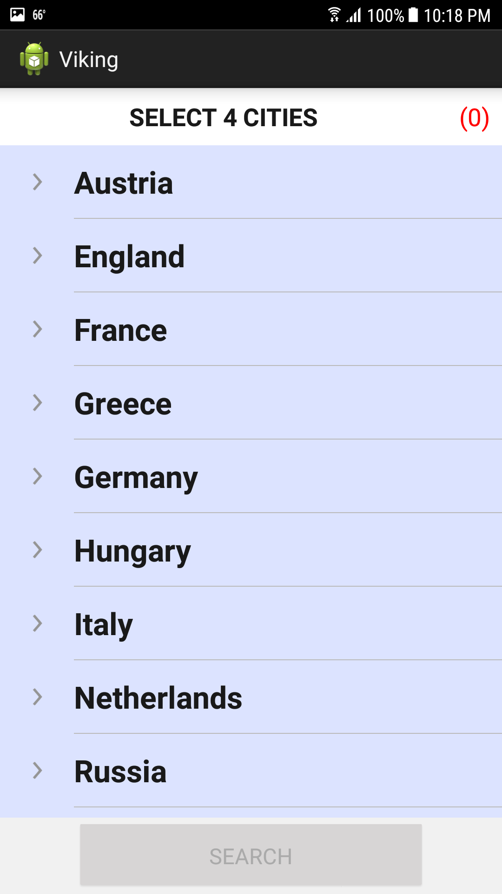

Figure . Main Screen

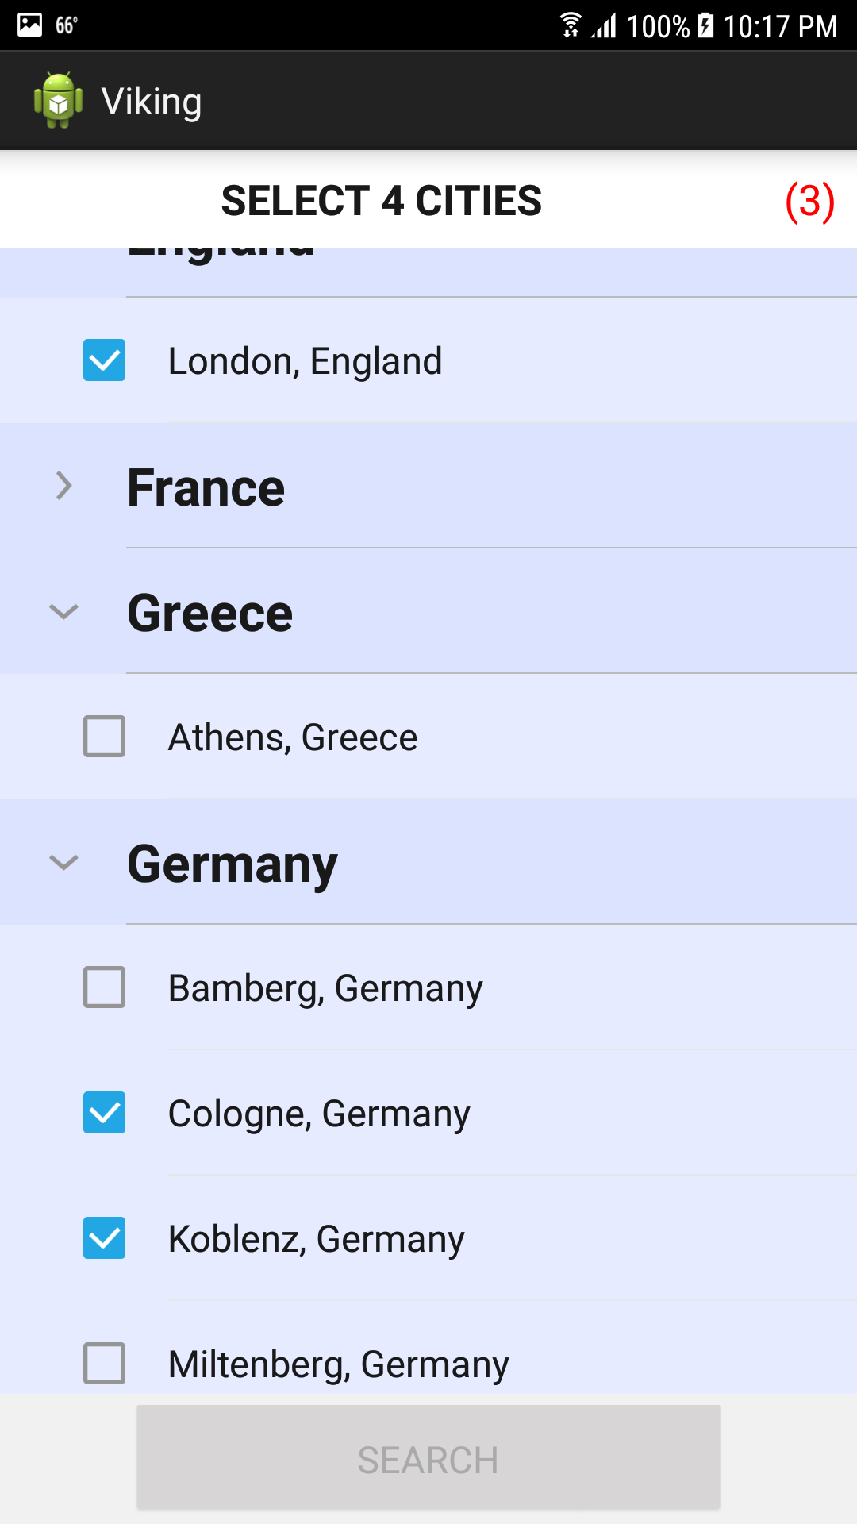

Figure . Select City

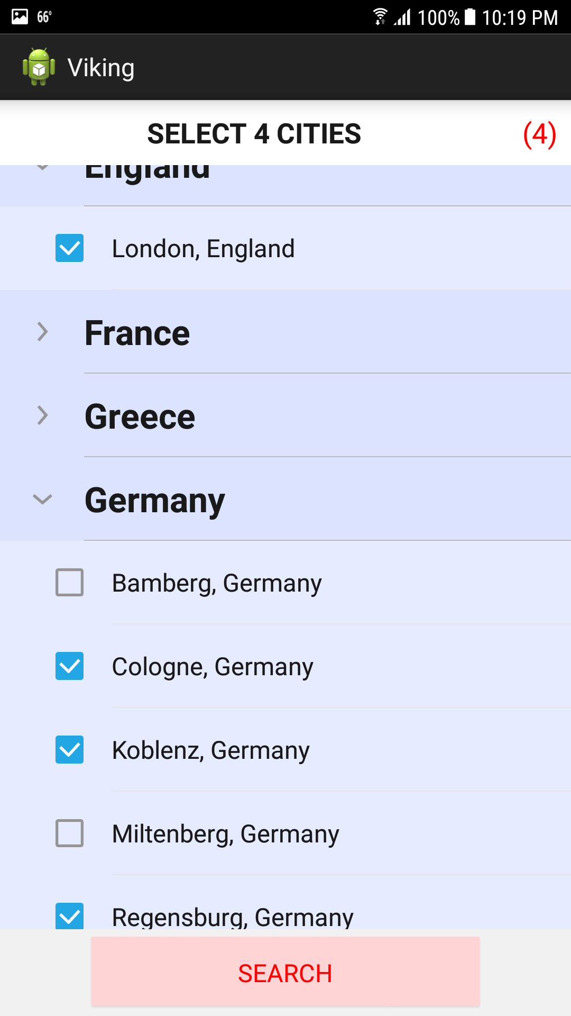

Figure . Enabled 'SEARCH' Button

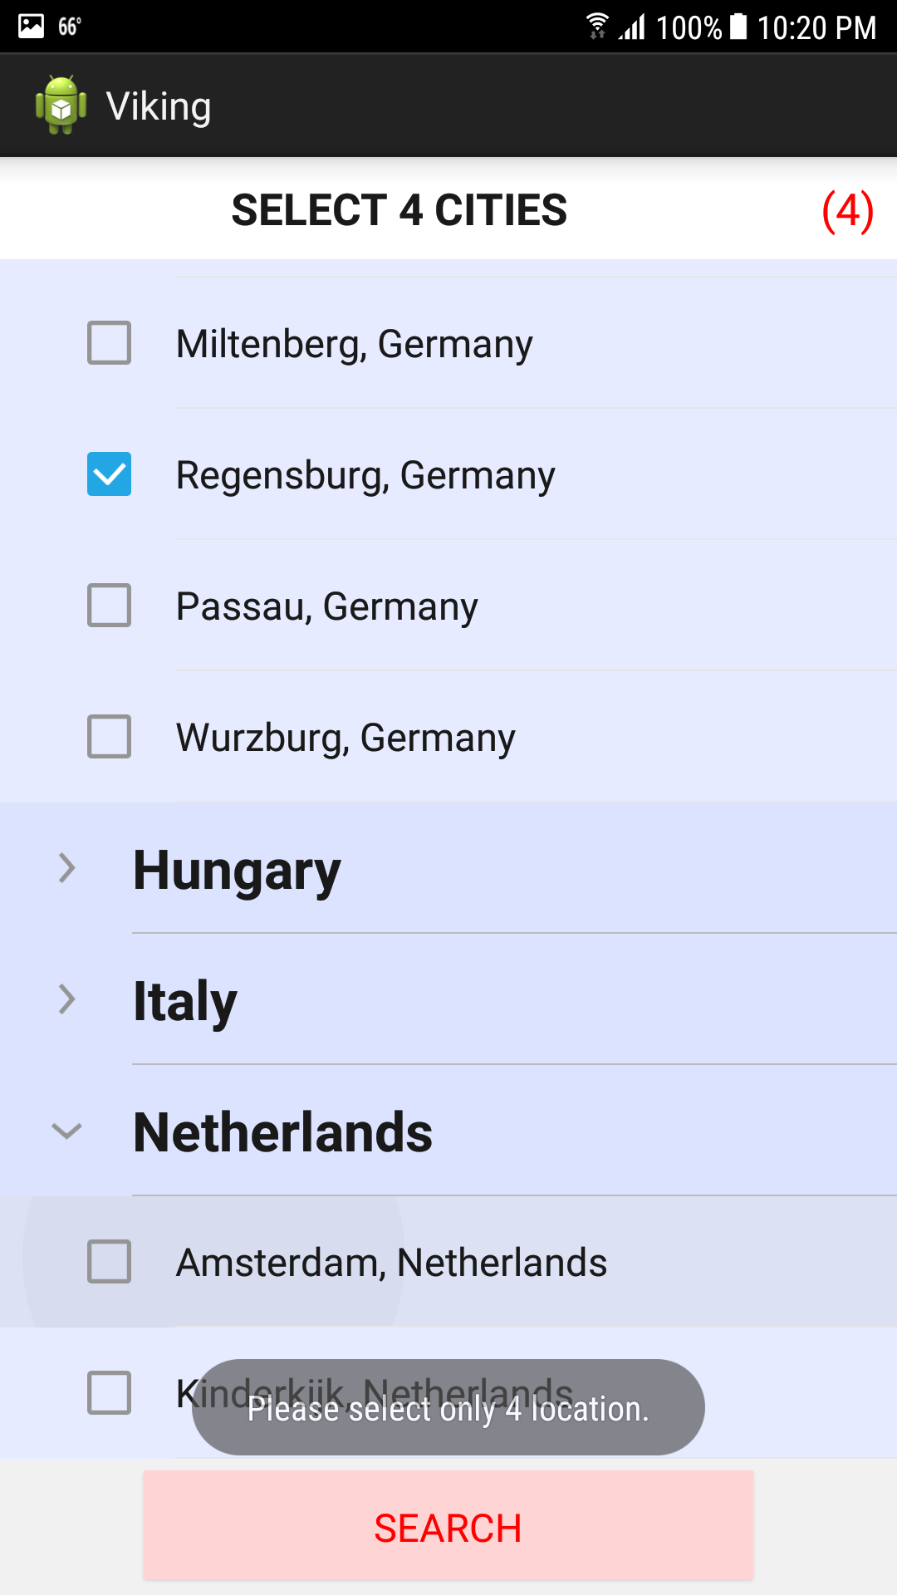

Figure . Toast Popup

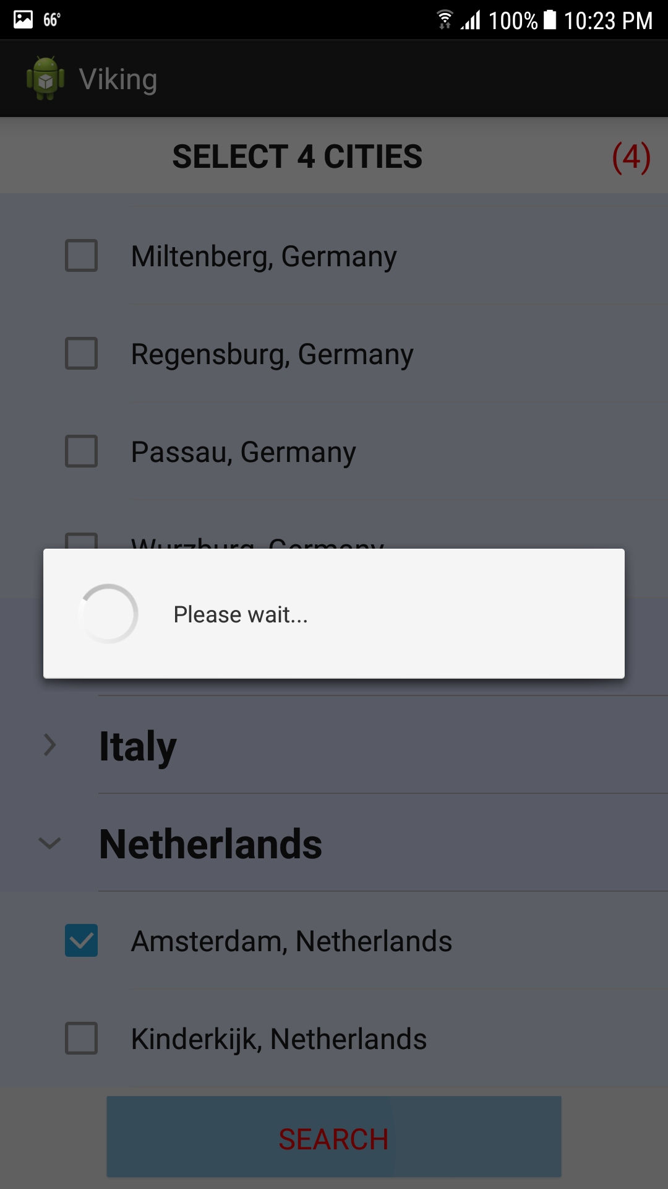

Figure . Loading

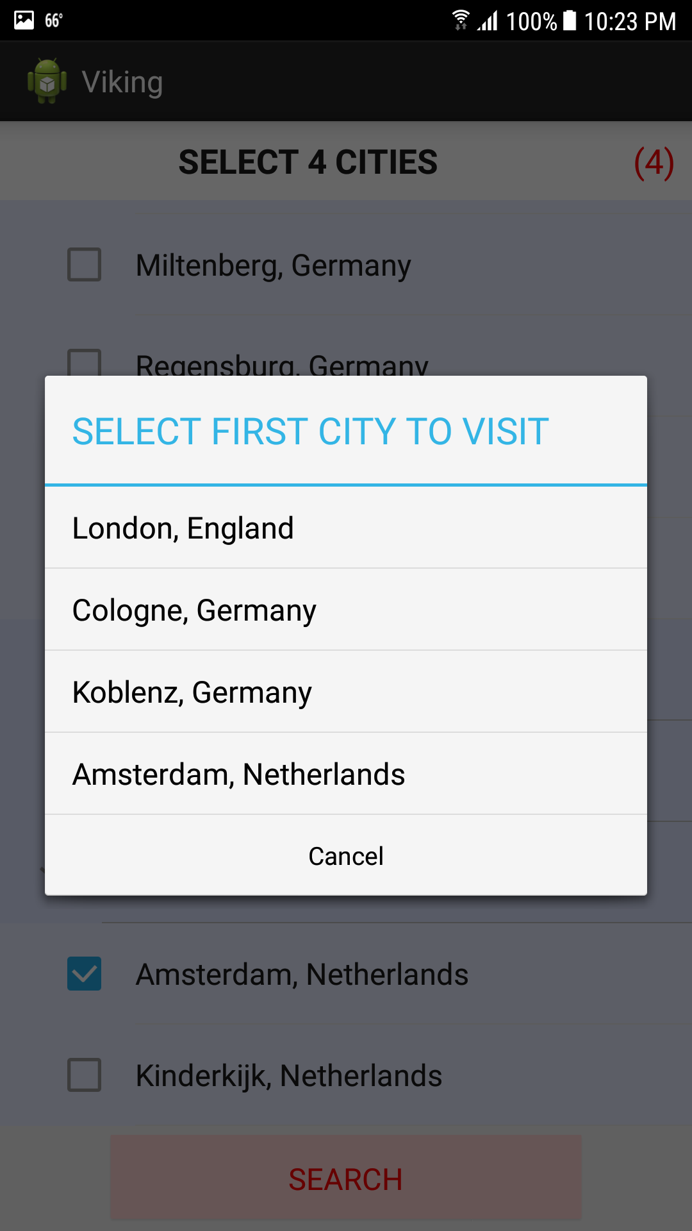

Figure . Show Selected Cities

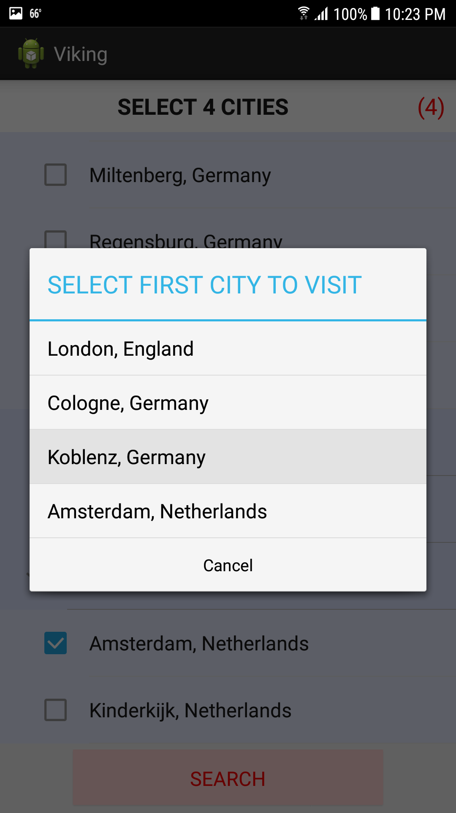

Figure . Select Start City

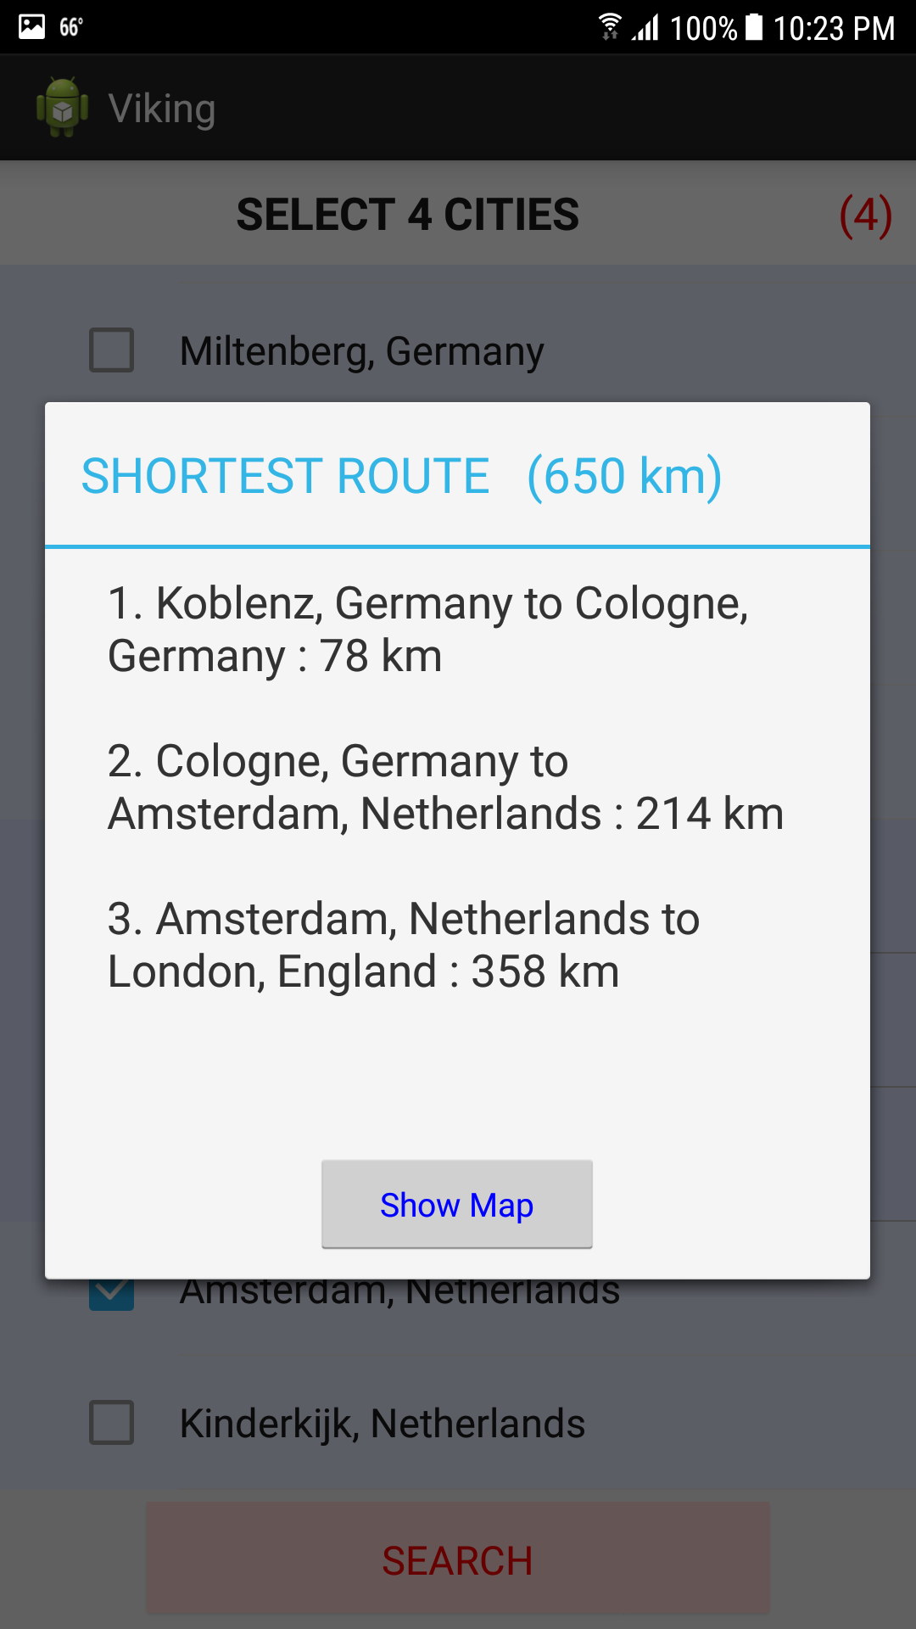

Figure . Show Shortest Route Result

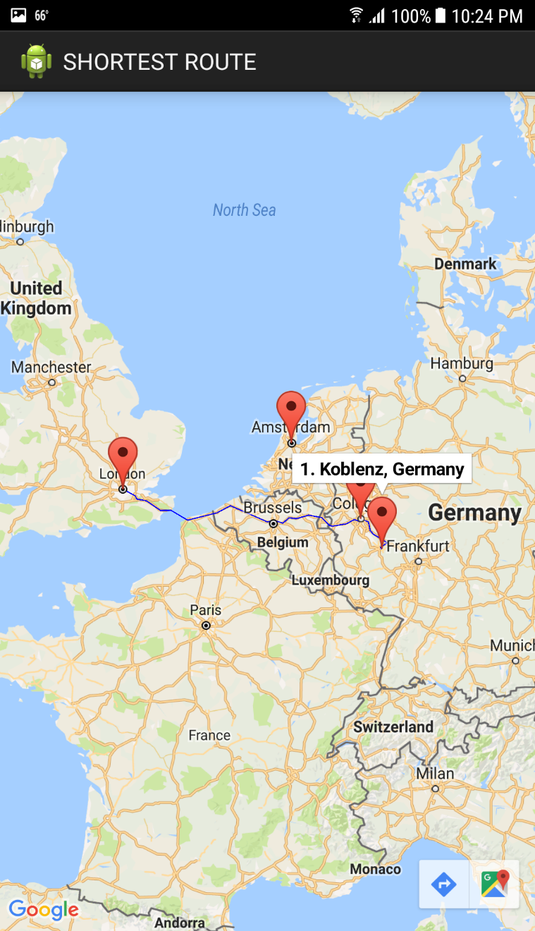

Figure . Show Route on the Map